1. Photos should be in horizontal line

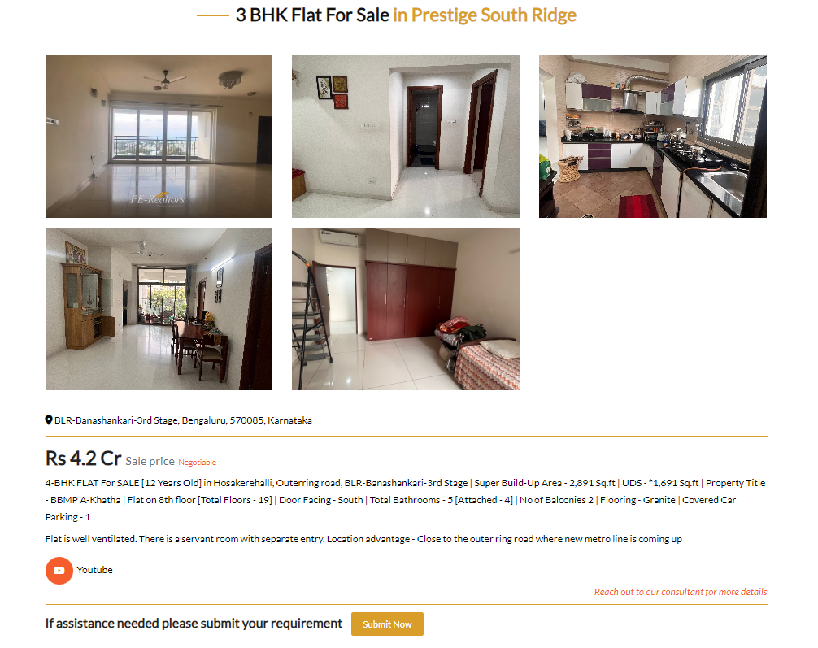

1. Make this 2 line property visible – The view looks good on desktop but on mobile second line is truanting.



1. Price word to be removed here

